Ooyala Backlot SharePoint Plugin Development
Technical Specification Document

Version: 0.1
Date: 23-August-2012

Submitted to:
Ooyala Backlot

By:
CSS Corp Pvt Ltd
3031 Tisch Way, Ste 1002, San Jose, CA 95128
Tel: 408-615-5700 Fax: 408-615-5707
URL: http://www.csscorp.com

Revision History
Version | Date | Revision Notes | Author(s)
0.1

Table of Contents

Objective 4
Overview 4
Solution Architecture 4
Share point Plug-In Architecture 4
OoyalaPlugIn dll 6
API Settings 8
Label Taxonomy 8
Upload From Local 9
Upload From SharePoint 9
Media Player Settings 9
Media Player 10
Thumbnail View 10
Detail View 10

Objective
The main idea of this project was to build a plug-in for sharepoint which user enables to communicate with Ooyala for upload the media asset, add/modify the label, add/modify the media players and view the media assets. Sharepoint is a good choice because we can collaborate the web part for authorized user. This documentation is aimed to readers who want to know more about the way it works and why and how technically.

Overview
Ooyala offers a modular, full-featured video solution. A brand new content type AUDIO, VIDEO can now be uploaded and managed directly in Backlot. The same functionality will satisfy by share point plug-in through Ooyala API. API libraries are available for generating and signing requests in the Java, PHP, Python, Ruby and C# languages. Using C# wrapper class, share point plug-in handling the REST operations.

Solution Architecture
The following diagram shows the high level solution architecture indicating the relationship between the different aspects of the overall system.

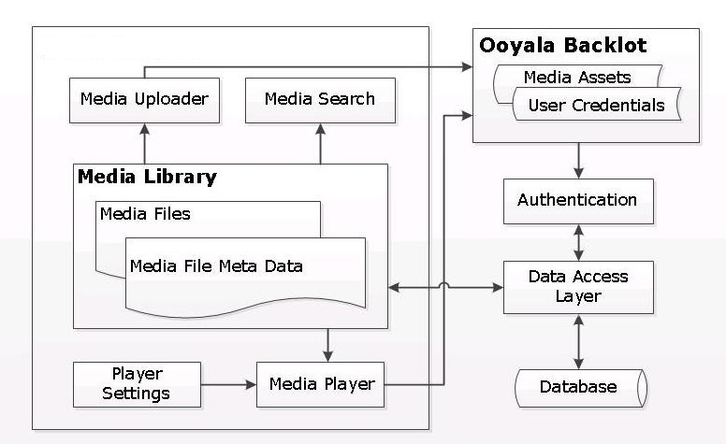

Share point Plug-In Architecture

Share point and .net provide a framework for share point Plug-In. The plug-In depends share point and .net framework dlls. The below figure show up the clean idea for how our plug-In communicate with share point environment and with other OoyalaAPI.

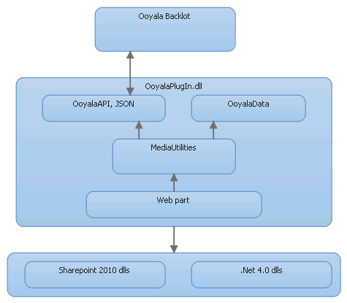Illustration 1: Share point Plug-In Architecture

The OoyalaPlugIn.dll depends the below dlls of Share point and .Net environment.
System.ServiceModel.Web.dll
System.Runtime.Serialzation.dll
System.Data.dll
Microsoft.SharePoint.dll
Mscorlib.dll
System.configuration.dll
System.Core.dll
System.Web.dll
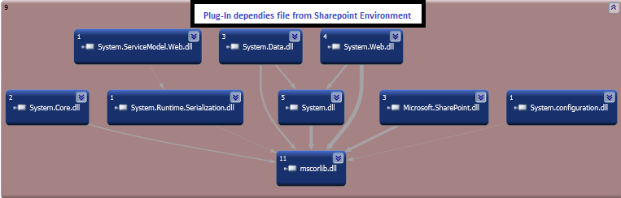Illustration 2: Sharepoint Environment dlls
The Microsoft.Sharepoint.dll help us to call from sandboxed solutions to APIs in SharePoint assemblies. Other than Microsoft.SharePoint.dll, are subject to the same restrictions as any other calls from sandboxed solutions. All APIs that are called are subject to the code access security (CAS) policy and the restricted security token of the sandboxed worker process.

The ServiceModel.Web.dll will help to serialize the JSON objects with .Net runtime. The System.Runtime.Serialzation.dll depends on System.ServiceModel.Web.dll. The System.Data.dll help us to communicate with ADO.Net object. Database communication related functionality we can achieve through this.

OoyalaPlugin.dll has 3 parts which are shown in next graphics.
- Web part classes
- MediaUtilities
- OoyalaAPI, OoyalaData

OoyalaPlugIn dll
We have common classes for communicating with Web part and Ooyala API
below points will help to understand each class functionality.

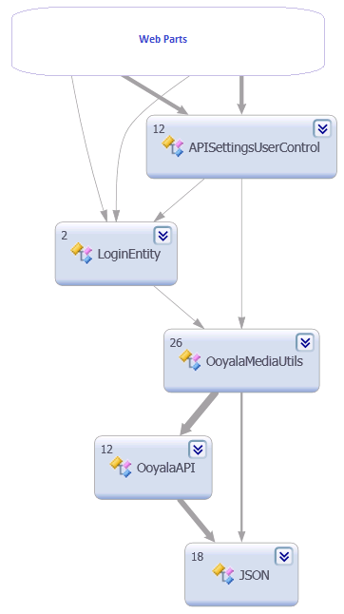Illustration 3: Class diagram

OoyalaMediaUtils : This class will lead the bridge between OoyalaAPI and web part. It will have the all methods for GET,PUT,PATCH, DELETE and POST operation for the Assets. Each and every result get by collections object. The ge t request will return output in collection objects as OoyalaData item type.
This class use the below dlls for security certificate validation.
using System.Security.Cryptography.X509Certificates;
using System.Net.Security;

OoyalaData : Its like wrapper class, it has all entity for Label, Media Players, and Media asses. The class entity will receive the all results and returned as collection.
Login Entity : This class will decide whether the passed API key and Secret key are valid. It will make a request though OoyalaMediaUtils to OoyalaAPI. It will make the request whether the 'Default player' available.
OoyalaAPI : This class will help us to access V2 API methods. Every web parts request will come through the ooyalaMediaUtils to OoaylaAPI. Here we can make an HTTP GET request to the Ooyala API with the specified path and using the given parameters and also Make a POST request to the Ooyala V2 API. Post request are used to create objects like Assets, Labels, Players, etc. PATCH requests are used to update data on objects and DELETE request to remove an object using the Ooyala V2 API.
JSON : The OoyalaAPI class communicate the JSON class. This class encodes and decodes JSON strings. JSON uses Arrays and Objects. These correspond here to the datatypes ArrayList and Hashtable.
JsonHelper : JSON Serialization and Deserialization Assistant Class
We have eight web parts, each web part having user control separately. The below picture will help us to understand the each web part class and control that all are how communicate with Media utilities class file and OoyalaAPI.

API Settings

The API Settings class will call the API Settings control based on Login entity out put. Login entity get the API key and Secret key based on share point user id. Then these keys will passed by Media utilities class for validate that whether the 'Default player' available on Ooyala Backlot, if player available it is a Valid API/Secret key. If valid user will store their keys into tblUser table. The below code make a request to Backlot for validate the credentails.
bool isValid = OoyalaMediaUtils.ValidateAPIInfo(SecretKey, APIKey);
if isValid true it will call the below method for store the credentials to database.
LoginEntity.SaveConfiguration(PartnerCode, SecretKey, APIKey, UserID))

Label Taxonomy

We are using .net Tree View control for maintain the label structure. When user request the Label plug-In,it will get the API/Secret keys based on logged share point id and it validated whether the user authorized person, if valid it will show the Label taxonomy page other wise it will navigate to API settings page and wait for user enter the valid API/Secret keys. The validation will happen at protected override void CreateChildControls() method.
The label class inherit the Web part class for adding new properties for Add/Edit/Delete label. It will make a request to OoyalaAPI with required parameters(API key, Secret Key, PathLabel contains a 'label' text and 'hs' is a hash table collection which contains required label details for create a new label).

For Add a Label: It will request the post method for Add a new label.
var res = OoyalaAPI.post(SecretKey, APIKey, pathLabel, hs);
For Edit a Label : It will request the patch method for Edit a label.
var res = OoyalaAPI.patch(SecretKey, APIKey, pathLabel + "/" + id, hs);
For Edit a Label : It will request the patch method for Delete a label.
var res = OoyalaAPI.delete(SecretKey, APIKey, pathLabel + "/" + id);

Upload From Local
When request the 'Upload from Local' plug-In it will get the API/Secret keys based on logged share point id and it validated whether the user authorized person, if valid it will show the 'Upload from Local' page other wise it will navigate to API settings page wait for user enter the valid API/Secret keys. The validation will happen at protected override void CreateChildControls() method.
This class inherit the Web part class for adding new properties for allow custom meta data and Allow Label. It will make a request to OoyalaAPI with required parameters(API key, Secret Key, FILE stream, Label and Custom metadata ).
public static void NewMediaUploadStream(string SecretKey, string APIKey, string id, Stream inStream)

Upload From SharePoint
When request the 'Upload from sharepoint' plug-In it will get the API/Secret keys based on logged share point id and it validated whether the user authorized person, if valid it will show the 'Upload from share point' page other wise it will navigate to API settings page wait for user enter the valid API/Secret keys. The validation will happen at protected override void CreateChildControls() method.
SPFolderCollection class collect all folders and files from share point site and it will display on .net tree view control.
This class inherit the Web part class for adding new properties for allow custom meta data and Allow Label. It will make a request to OoyalaAPI with required parameters(API key, Secret Key, FILE stream, Label and Custom metadata ).
public static void NewMediaUploadStream(string SecretKey, string APIKey, string id, Stream inStream)

Media Player Settings
When request the 'Media Player Settings' plug-In it will check the API/Secret keys based on logged share point id and it validated whether the user authorized person, if valid it will show the 'Media Player Settings' page other wise it will navigate to API settings page wait for user enter the valid API/Secret keys. The validation will happen at protected override void CreateChildControls() method.
This class inherit the Web part class for adding new properties for allow Add\Edit\Delete the Media players. It will make a request to OoyalaAPI with required parameters(API key, Secret Key, player).
The below method make a request to get the all player and assigned it to in GridView with Player id, Player name and is default player check box.
List<OoyalaData.Players.Item>players= OoyalaMediaUtils.GetAllPlayers(SecretKey, APIKey);
The button event will help to get the row index for Edit/Delete operations. It will get the row index and make a POST and PATCH request for Edit/Delete operations.

OoyalaAPI.delete(SecretKey, APIKey, pathPlayer + "/" + id);

Media Player
When request the 'Media Player' plug-In it will check the API/Secret keys based on logged share point id and it validated whether the user authorized person, if valid it will show the 'Media Player' page other wise it will navigate to API settings page wait for user enter the valid API/Secret keys. The validation will happen at protected override void CreateChildControls() method.
The Web part has two drop down for list the player if and asses id.
var assets = OoyalaMediaUtils.GetLiveAssets(SecretKey, APIKey);
var players = OoyalaMediaUtils.GetAllPlayers(SecretKey, APIKey);
The selected player id and asset id will passed as parameters to below function. The player will on particular div id.
<script src='https://player.ooyala.com/v3/player id'></script>
<div id='playerwrapper' style='width:640px;height:380px;'></div>
varvideoPlayer= OO.Player.create('playerwrapper','Assest Id');

Thumbnail View
When request the 'Thumbnail View' plug-In it will check the API/Secret keys based on logged share point id and it validated whether the user authorized person, if valid it will show the 'Thumbnail View' page other wise it will navigate to API settings page wait for user enter the valid API/Secret keys. The validation will happen at protected override void CreateChildControls() method.
This class inherit the Web part class for adding new properties for allow Search, Column size and Row size the Thumbnail View. Invoke the search button it will get result set and it will display on Data list.
cdata = OoyalaMediaUtils.GetLimitedAssets(SecretKey, APIKey, pageSize, searchBy, searchText, page_token,false,false);
It will keep the page_token value on view state and it will passed to methods based on previous and Next button.
The below logic construct the query to get the all assets
if (IncludeLabels && IncludeMetadata)
parameters.Add("include", "metadata,labels");
else if (IncludeLabels && !IncludeMetadata)
parameters.Add("include", "metadata");
else if (!IncludeLabels && IncludeMetadata)
parameters.Add("include", "labels");

if (searchBy.Contains("metadata")) //for metadata when searchtext is empty value search
parameters.Add("where", string.Format(formatSearch, searchBy, searchText));
else if(!string.IsNullOrEmpty(searchText))
parameters.Add("where", string.Format(formatSearch, searchBy, searchText));

Detail View

When request the 'Detail View' plug-In it will check the API/Secret keys based on logged share point id and it validated whether the user authorized person, if valid it will show the 'Details View' page other wise it will navigate to API settings page wait for user enter the valid API/Secret keys. The validation will happen at protected override void CreateChildControls() method.
This class inherit the Web part class for adding new properties for allow Search, Page size, Allow Add/Edit/Delete Asset for Details View.
The below methods will delete the when invoke the delete button
var res=OoyalaMediaUtils.DeleteMediaAsset(SecretKey, APIKey, id);
The below methods will help build the query and return result set to Grid view when click the search button.
cdata = OoyalaMediaUtils.GetLimitedAssets(SecretKey, APIKey, pageSize, searchBy, searchText, page_token,false,false);
It will keep the page_token value on view state and it will passed to methods based on previous and Next button.
The below logic construct the query to get the all assets
if (IncludeLabels && IncludeMetadata)
parameters.Add("include", "metadata,labels");
else if (IncludeLabels && !IncludeMetadata)
parameters.Add("include", "metadata");
else if (!IncludeLabels && IncludeMetadata)
parameters.Add("include", "labels");

if (searchBy.Contains("metadata")) //for metadata when searchtext is empty value search
parameters.Add("where", string.Format(formatSearch, searchBy, searchText));
else if(!string.IsNullOrEmpty(searchText))
parameters.Add("where", string.Format(formatSearch, searchBy, searchText));

